**AIML**

Project Report

Semester-IV (Batch-2022)

CAR PRICE PREDICTION



**Supervised By: Submitted By:**

Mr Mohammad Talib 2210992344: Shreya Thakur

2210992348: Shreyashi Singh

2210992353: Shriya Seth

2210992354: Shruti

**Department of Computer Science & Engineering**

**Chitkara University Institute of Engineering and Technology, Chitkara University, Punjab**

**Abstract:**

With the rapid growth of the automotive market in China, accurate prediction of car prices has become increasingly important for manufacturers, dealers, and consumers alike. In this study, we present a machine learning-based approach implemented by a Chinese company to forecast car prices based on key influencing factors.Utilizing a rich dataset encompassing various attributes such as car specifications, historical sales data, consumer preferences, economic indicators, and market trends specific to the Chinese automotive landscape, we develop and deploy predictive models to anticipate future price trends.Our methodology involves data preprocessing techniques tailored to handle the nuances of the Chinese automotive market, including encoding categorical variables and addressing data sparsity issues. We employ feature selection methods to identify the most informative attributes, focusing on factors such as brand reputation, model popularity, engine specifications, fuel efficiency, government policies, and regional demand patterns.

The results of our study demonstrate the efficacy of machine learning techniques in predicting car prices in the context of the Chinese automotive industry. By leveraging advanced analytics and domain-specific insights, the developed models offer a valuable tool for stakeholders to navigate the complexities of pricing dynamics and drive business success in the burgeoning Chinese car market.

**INDEX**

| **S No.** | **Topics** | **Page No.** |
| --- | --- | --- |
| **1.** | **Introduction** | **4-5** |
| **2.** | **Feature Description** | **6** |
| **3.** | **Problem Statement/Future Scope** | **7-8** |
| **5.** | **Conclusion** | **9** |
| **6.** | **Snapshots of Project** | **10-12** |

1. **Introduction:**

**Car Price Prediction**

In recent years, the automotive industry in China has experienced unprecedented growth, emerging as one of the world's largest and most dynamic markets. With a burgeoning middle class, rapid urbanization, and increasing disposable incomes, the demand for cars in China has surged, driving significant transformations in the automotive landscape. In this context, accurate prediction of car prices has become a critical concern for manufacturers, dealers, and consumers seeking to navigate the complexities of this dynamic market.

**1.1 Background:**

This study focuses on elucidating the methodology and findings of a car price prediction project undertaken by a Chinese company, aimed at harnessing ML techniques to anticipate price trends in the Chinese automotive market. By analyzing a comprehensive dataset encompassing a myriad of factors, ranging from car specifications to economic indicators and consumer preferences, the company endeavors to develop robust predictive models capable of capturing the intricate relationships driving pricing dynamics.The significance of this endeavor lies in its potential to revolutionize pricing strategies and business operations within the Chinese automotive industry. By leveraging ML algorithms and domain-specific insights, the company seeks to not only predict car prices accurately but also gain valuable insights into the underlying factors shaping market trends. These insights, in turn, empower stakeholders to make informed decisions, optimize resource allocation, and capitalize on emerging opportunities in the rapidly evolving automotive landscape.

**1.2 Objective:**

The objective of the project is to perform an exploratory data analysis, data pre-processing, data cleaning and at the end, apply different Data Visualization techniques to get the meaningful insight from the given data. This project aims applying some amazing Python Libraries like as matplotlib , seaborn which will give a boost to our visual understanding of the data.

**1.3 Significance:**

The significance of the car price prediction project in the Chinese automotive industry lies in its potential to address several key challenges and unlock numerous opportunities for stakeholders:

**1.Market Competitiveness:** In the highly competitive Chinese automotive market, accurate price prediction provides companies with a strategic advantage. By understanding future price trends, companies can adjust their pricing strategies to stay competitive, attract customers, and maintain market share.

**2.Profitability Optimization:** Pricing decisions directly impact a company's profitability. By accurately predicting car prices, companies can optimize pricing strategies to maximize revenue while ensuring profitability. This involves setting prices that align with market demand, consumer preferences, and cost considerations.

**3.Resource Allocation:** Efficient resource allocation is essential for maximizing returns on investment and minimizing costs. Predictive models help companies allocate resources such as marketing budgets, production capacities, and inventory levels more effectively by anticipating future demand and pricing trends.

**4.Inventory Management:** Car manufacturers and dealers face challenges related to inventory management, including balancing supply and demand, minimizing inventory costs, and avoiding stockouts or overstock situations. Accurate price prediction enables companies to optimize inventory levels, reduce carrying costs, and improve inventory turnover rates.

**5.Consumer Satisfaction:** Pricing plays a significant role in shaping consumer perceptions and purchase decisions. By pricing cars competitively and transparently, companies can enhance customer satisfaction and loyalty, leading to increased repeat purchases and positive word-of-mouth recommendations.

**1.4 Features description:**

**(i)id:** Unique for each Car

**(ii)CarName:** Name of the car

**(iii)FuelType :** type of fuel in car

**(iv)HorsePower:** power produced by engine

**(v)DoorNumber:** Number of doors a car have

**(vi)EngineSize:** Size of the engine

**(vii)CylinderNumber :** Number of engine that a car have

**1.5 Technology Used:**

* Google colab is used as IDE.
* Pandas and NumPy are used for Data Manipulation & Pre-processing and Mathematical functions respectively.
* Exploratory data analysis is automated by data prep.
* For visualization of the plots, Matplotlib, Seaborn are used.
* GitHub is used as version control system

**2.1 Problem Statement:**

A Chinese automobile company Geely Auto aspires to enter the US market by setting up their manufacturing unit there and producing cars locally to give competition to their US and European counterparts.

They have contracted an automobile consulting company to understand the factors on which the pricing of cars depends. Specifically, they want to understand the factors affecting the pricing of cars in the American market, since those may be very different from the Chinese market. The company wants to know:Which variables are significant in predicting the price of a car How well those variables describe the price of a car Based on various market surveys, the consulting firm has gathered a large data set of different types of cars across the America market.

**Complexity in Product Selection:** The wide range of printer models, brands, and specifications available on the market often overwhelms customers, making it difficult for them to identify the most suitable car that meets their specific printing needs and budget constraints.

**2.2 Hardware Requirements:**

**Computer:**A desktop or laptop computer capable of running colab.

**Internet Connection:**Required for accessing online resources and testing the dataset.

**3.Future Scope:**

The future scope of the car price prediction project in the Chinese automotive industry is expansive, encompassing a wide range of opportunities for innovation, optimization, and strategic growth. By leveraging advanced analytics and machine learning capabilities, companies can stay ahead of market trends, drive operational excellence, and unlock new avenues for value creation in the dynamic automotive landscape.

**1. Artificial Intelligence (AI) and Machine Learning (ML) Capabilities:**

- Utilize AI-powered chatbots for personalized customer support, order tracking, and product recommendations based on user preferences and past behavior.

- Implement ML algorithms for predictive maintenance of printers, analyzing usage patterns and identifying potential issues before they occur.

**2. Data Analytics and Business Intelligence:**

- Leverage data analytics tools to gain actionable insights into customer behavior, purchasing patterns, and market trends, enabling data-driven decision-making and targeted marketing campaigns.

- Utilize business intelligence dashboards for real-time monitoring of key performance indicators (KPIs), sales metrics, and customer satisfaction levels, optimizing operational efficiency and performance.

1. **Conclusion:**

Concluding a car price prediction project involves summarizing the findings, evaluating the model's performance, and suggesting potential areas for improvement or future research

summarizing the main findings of your car price prediction project. Highlight the key insights gained from the analysis and model development process.

Evaluate the performance of the car price prediction model. Discuss metrics such as accuracy, precision, recall, and F1-score (if applicable).

Discuss the most influential factors identified during the analysis. This could include variables such as make, model, year, mileage, condition, location, and features.

Acknowledge the limitations of the study. This could include data limitations, model assumptions, or constraints that may have impacted the accuracy or generalizability of the results.

Suggest potential avenues for future research or improvements to the car price prediction model.

Summarize the main takeaways from the project and reiterate its significance. Emphasize the value of accurate price prediction in the automotive industry and the potential benefits of further research in this area.

**5. Snapshots of Project:**

**Scatter Plot**

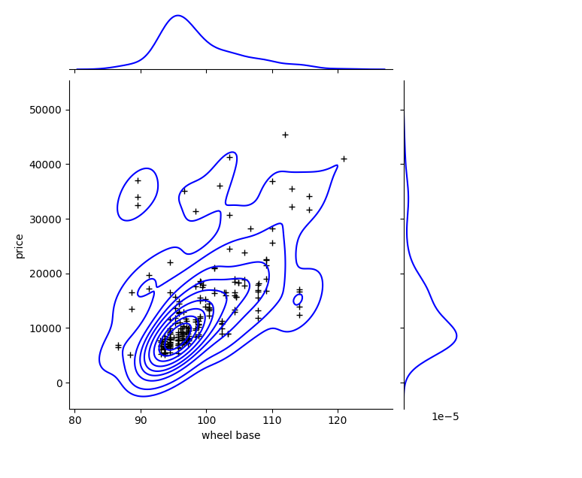

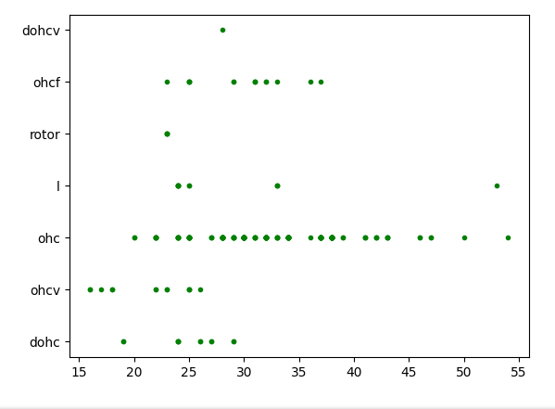

**Pie Plot**

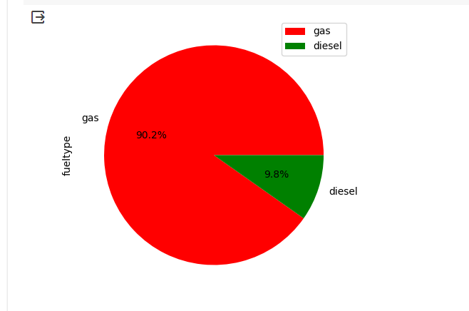

**ML Model Implementation**

